**EXPERIMENTAL STAND RAPORT**

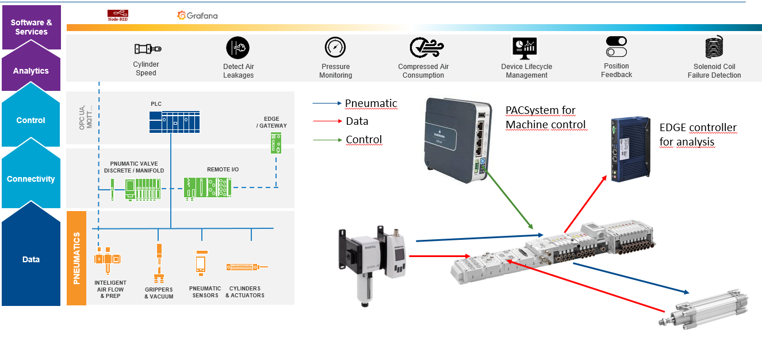

**AUTHORS: COORDINATOR:**

**Fecher Alexandra Ghinea Mihalache**

**Hasciar Vlad**

**Antonie Daria**

**Oncioiu Cosmin**

Bucharest 2022

# Contents

1. General description
2. Components
3. Tehnical specifications on each component
4. Principle of functioning
5. IIoT stand integration
6. **General description**

This is testing and research equipment made to gather data about pneumatic systems, and especially pneumatic pistons, capabilities, optimal parameters, limits, and the way normal wear affect it’s functionality.

It is meant to collect data, graph it, analyse it and perform predictive maintenance.

1. **Components**

* PACSystem RSTi-EP
* EDGE Contoller
* 3/2 shut off valve
* Filter pressure regulator
* 3/2 directional valve
* Sensor pressure with display
* Expansion module EP-2218
* Profile cylinder (0822122009)
* Profile cylinder (0822123009)
* Profile cylinder (0822121011)
* Profile cylinder (0822123011)
* Compresor PARKSIDE
* Aventics series AES (R412088223)
* Valve system series CD10-PI

**3) Technical specifications on each component**

* 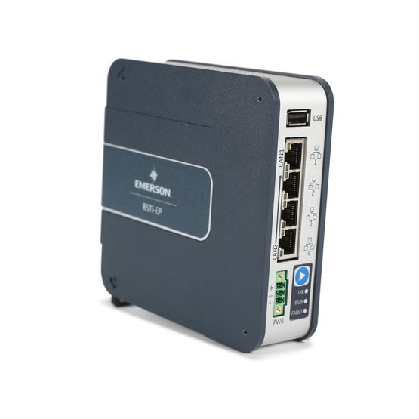**PACSystem RSTi-EP**

**Specifications**

* Part Number: EPSCPE115
* Storage: 1.5MB
* I/O2k Bits Discrete I/O, 32k Words for Analog I/O
* Redundancy SupportMedia Redundancy Protocol (MRP)
* Ethernet Communications: SRTP Client/Server (Max 8 Connections), Modbus TCP/IP (Max 8 Connections), OPC-UA Server (Max 8 Clients), EDG (Max 16 Exchanges), PROFINET (Max 8 IO Devices)
* USB1x USB-A 2.0
* Memory Card Micro SD
* Ethernet Port1x 10/100, 1x 3-port switch 10/100
* Other Interface1x RS-232

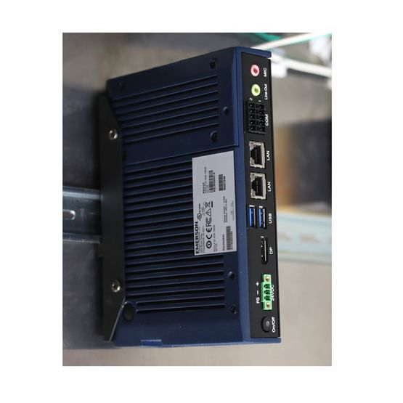

* **EDGE Controller**

**Specifications**

* Part Number: R2L0N1A2AD
* Software: PACEdge
* Operating System: Ubuntu Linux
* Processor: AMD G-Series SOC 2nd Generation GX-210HL Processor, 7W 2c 1.0GHz 1MB cache
* Memory: 4GB DDR3L
* Storage: 32GB SSD
* Ethernet2x 1-gigabit Ethernet channels - RJ-45 standard
* USB2x USB 3.0 external
* Serial Interfaces1x RS232, 1x RS422/485 RTC
* Certifications: UL, CE, FCC, RoHS, ATEX, IECEx
* Marine: ABS, BV, DNV GL, LR
* UL Listed US/CAN HazLocClass 1 Division 2, Class 2 Division 2, Class 3 Division 1
* Expansion Slots0 Slot
* Operating Temperature – 30 °C to 65 °C

**• 3/2 shut off valve**

**Specifications**

* Standards ISO 5599-2, ISO 1
* Working pressure min./max. -1/10 bar
* Ambient temperature min./max. -10/50 °C
* Medium temperature min./max. 0/50 °C
* Medium Compressed air
* Nominal flow Qn 1400 l/min
* Operational voltage electronics 24 V DC
* Number of valve positions max. 12
* Protection class with connection IP65
* DC operating voltage 24 V
* Voltage tolerance DC -10% / +10%

**• Filter pressure regulator**

* A picture containing electronics, different, several, adapter

  Description automatically generated**3/2 directional valve**

**Specifications**

* Standards ISO 5599-2, ISO 1
* Working pressure min./max. -1/10 bar
* Ambient temperature min./max. -10/50 °C
* Medium temperature min./max. 0/50 °C
* Medium Compressed air
* Nominal flow Qn 1400 l/min
* Operational voltage electronics 24 V DC
* Number of valve positions max. 12
* Protection class with connection IP65
* DC operating voltage 24 V
* Voltage tolerance DC -10% / +10%
* **Sensor pressure with display**

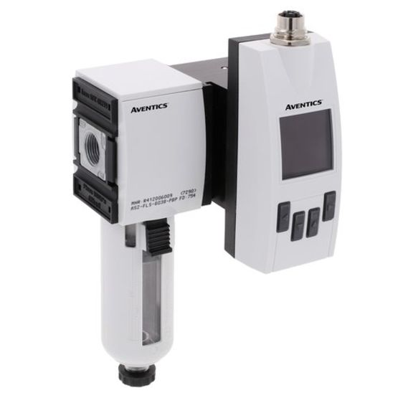**Specifications**

* + - Frame size AS2
    - Switching principle Flow measuring principle: calorimetric
    - Nominal flow Qn min., Standard5 l/min
    - Nominal flow Qn max., Standard1060 l/min
    - Nominal flow Qn min., extended1060 l/min
    - Nominal flow Qn max., extended1590 l/min
    - Compressed air connection G 3/8
    - Certificates CE declaration of conformity, RoHS
    - Working pressure min.0 bar
    - Working pressure max16 bar
    - Min. ambient temperature-20 °C
    - Max. ambient temperature60 °C
    - Min. medium temperature-20 °C
    - Max. medium temperature60 °C
    - Medium Carbon dioxide, Helium, Argon, Compressed air, Nitrogen
    - filter porosity 5 µm
    - Display OLED
    - Flow display unit ft³/s, m³/min, l/sec, m³/h, l/min
    - Pressure display unit psi, bar
    - Temperature display unit °C, °F
    - Electrical connection 5-pin
* A close-up of an object

  Description automatically generated with low confidence**Profile cylinder (0822122009)**

**Specifications**

* StandardsISO 15552
* Piston Ø50 mm
* Hub 320 mm
* Principle double-acting
* Damping pneumatically adjustable damping
* Magnetic pistons Piston with magnet
* Environmental Requirements Industry standard, ATEX optional
* Certificates ATEX optional
* Rod unilateral
* Wiper Standard Industrial Wiper
* Pressure for determining piston forces6.3 bar
* Piston force retracting1035 N
* Piston force extending1235 N
* Ambient temperature min.-20 °C
* Ambient temperature max.80 °C
* Operating pressure min.1.5 bar
* Operating pressure max.10 bar
* Connections G 1/4
* Piston rod threadM16x1.5
* Damping length17 mm
* Attenuation energy15 years
* Weight 0 mm stroke1.06 kg
* Weight +10 mm stroke0.047 kg
* Hub max.2100 mm
* Medium Compressed air
* A close-up of an object

  Description automatically generated with low confidence**Profile cylinder**

**Specifications**

* Standards ISO 15552
* Piston Ø63 mm
* Hub 500 mm
* Principle double-acting
* Damping pneumatically adjustable damping
* Magnetic pistons Piston with magnet
* Environmental Requirements Industry standard, ATEX optional
* Certificates ATEX optional
* Rod unilateral
* Wiper Standard Industrial Wiper
* Pressure for determining piston forces 6.3 bar
* Piston force retracting1765 N
* Piston force extending1960 N
* Ambient temperature min.-20 °C
* Ambient temperature max.80 °C
* Operating pressure min.1.5 bar
* Operating pressure max.10 bar
* ConnectionsG 3/8
* Piston rod thread M16x1.5
* Damping length16.5 mm
* Attenuation energy 27 years
* Weight 0 mm stroke1.42 kg
* Weight +10 mm stroke0.054 kg
* Hub max. 2500 mm
* Medium Compressed air
* A close-up of an object

  Description automatically generated with low confidence**Profile cylinder (0822121011)**

**Specifications**

* Standards ISO 15552
* Piston Ø40 mm
* Hub 500 mm
* Principle double-acting
* Damping pneumatically adjustable damping
* Magnetic pistons Piston with magnet
* Environmental Requirements Industry standard, ATEX optional
* Certificates ATEX optional
* Rod unilateral
* Wiper Standard Industrial Wiper
* Pressure for determining piston forces6.3 bar
* Piston force retracting660 N
* Piston force extending790 N
* Ambient temperature min.-20 °C
* Ambient temperature max.80 °C
* Operating pressure min.1.5 bar
* Operating pressure max.10 bar
* Connections G 1/4
* Piston rod thread M12x1.25
* Damping length19 mm
* Attenuation energy9 J
* Weight 0 mm stroke0.65 kg
* Weight +10 mm stroke0.032 kg
* Hub max.1900 mm
* Medium Compressed air
* 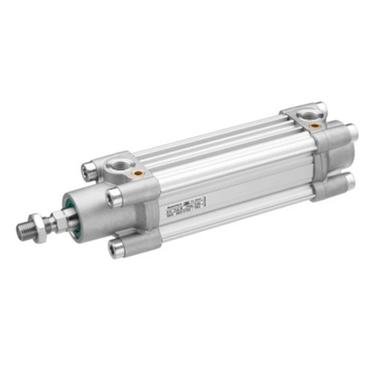**Profile cylinder (0822123011)**

**Specifications**

* StandardsISO 15552
* Piston Ø40 mm
* Hub500 mm
* Principledouble-acting
* Dampingpneumatically adjustable damping
* Magnetic pistonsPiston with magnet
* Environmental RequirementsIndustry standard, ATEX optional
* CertificatesATEX optional
* Rodunilateral
* WiperStandard Industrial Wiper
* Pressure for determining piston forces6.3 bar
* Piston force retracting660 N
* Piston force extending790 N
* Ambient temperature min.-20 °C
* Ambient temperature max.80 °C
* Operating pressure min.1.5 bar
* Operating pressure max.10 bar
* ConnectionsG 1/4
* Piston rod threadM12x1.25
* Damping length19 mm
* Attenuation energy9 J
* Weight 0 mm stroke0.65 kg
* Weight +10 mm stroke0.032 kg
* Hub max.1900 mm
* Medium Compressed air
* A picture containing tool

  Description automatically generated**Compresor PARKSIDE**

**Specifications**

* Mains connection 230 V ~ 50 Hz
* Motor rating W 1800
* Operating mode S1
* Compressor speed min-12850
* Pressure vessel capacity (in liters) 24
* Operating pressure approx. 8 ba
* Theoretical intake capaci-ty (l/min)approx. 270
* Sound power level LWA97 dB(A)
* Uncertainty KWA4 dB
* Protection type IP20
* Weight of the unit in kg 26
* Oil (15W 40) l 0,3
* Max. altitude (above mean sea level) 1000 m
* A picture containing camera

  Description automatically generated**Aventics series AES (R412088223)**

**Specifications**

* Version Bus coupler
* Fieldbus protocol PROFINET IO
* Electrical connection type Plug (male)
* Electrical connection size M12
* Electrical connection number of poles 4-pin
* Electrical connection coding A-coded
* Fieldbus design D-design
* Type Generation 2
* Note Fieldbus connection with I/O functionality
* Min. ambient temperature -10 °C
* Max. ambient temperature 60 °C
* Number of solenoid coils max. 128
* Max. number of valve positions 64
* Operational voltage electronics 24 V DC
* Electronics voltage tolerance -25% / +25%
* Power consumption electronics 0.1 A
* Operating voltage, actuators 24 V DC
* Total current for actuators 4 A
* Protection class IP65
* Cycle time at 256 bits< 1 ms
* Logic/actuator voltage Galvanically isolated
* Diagnosis Short circuit, Undervoltage
* I/O module extension max.10
* Generic emission standard in accordance with normEN 61000-6-4
* Generic immunity standard in accordance with normEN 61000-6-2
* **Valve system series CD10-PI**

**Specifications**

* Standards ISO 5599-2, ISO 1
* Working pressure min./max. -1 ... 10 bar
* Ambient temperature min./max. -10 ... 50 °C
* Medium temperature min./max. 0 ... 50 °C
* Medium Compressed air
* Nominal flow Qn 1400 l/min
* Operational voltage electronics 24 V DC
* Number of valve positions max. 12
* Protection class with connection IP65
* DC operating voltage 24 V
* Voltage tolerance DC -10% / +10%

1. **Principle of functioning**

The *RSTi-EP PACSystem* controls the behaviour of the system and can be programmed using *Proficy Machine Edition.*

The *EDGE controller* is used to gather data, process it, graph it and making it easily accessible.

The *BUS coupler* is used to connect the *PACSystem* to the outputs and inputs of the system as well as transmitting the data to the *EDGE controller*.

The *valves* controll the flow of air, moving the *pistons*.

The *input*s are *sensors* connected to the extremities of the *pistons* for detection of the *rod's* position.

The *AF2  IO-Link* measures the pressure and flow , transmitting it to the *BUS coupler*.

1. **IIoT stand integration**

IIoT integration is done using the EDGE controller, having remote acces capabilities it can make the collected data accesibile to other devices, including a remote server used for data storage.